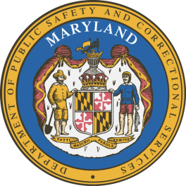
Application for Certificate of

Rehabilitation and Certificate of Completion

I am applying for (choose one option only):

Certificate of Completion

Certificate of Rehabilitation

Applicant Information
Name:
Date of birth: |  |  |  |  | Phone:
Current address:
City: | State: |  |  |  | ZIP code:
Driver’s license #: |  |  | Email address:
Other names used/Aliases:

Supervision Information
Current offense:
Date of sentence: |  | Date of arrest:
Court location: |  | Court docket #:  Fax:
Office where you were supervised: |  |  |  | Supervision expiration date:  ZIP Code:
Parole and Probation case #:
Hourly Salary (Please circle)
Annual income:
The applicant agrees to allow an investigation to be made to determine his or her eligibility for a Certificate of Completion or Rehabilitation.

FOR CERTIFICATE OF REHABILITATION APPLICANTS ONLY:

I authorize any investigator, special agent, or other duly accredited representative of the Department of Public Safety and Correctional Services to obtain any information relating to my criminal history to include arrest and conviction history. I further authorize the Department of Public Safety and Correctional Services to request criminal record information about me from criminal justice agencies for the purpose of determining my eligibility. I authorize custodians of records and sources of information pertaining to me to release such information upon request of the investigator, special agent, or other duly accredited representative of the Department of Public Safety and Correctional Services. I understand that the information released by records custodians and sources of information is for official use by the State of Maryland only for the purposes of determining my eligibility for a Certificate of Rehabilitation.
Signature of applicant: |  |  |  |  |  | Date:

Please email the completed application to dpp.pio@maryland.gov or it can be delivered in person to any Maryland Division of Parole and Probation Field Office.

